Stage 6 – Home Port
COURSE DESIGNER: Aaron Banks
SCORING: Comstock 28 rounds.
TARGETS: 9 cardboard targets, 6 steel targets
SCORED HITS: 3 Best hits per carboard will be scored.
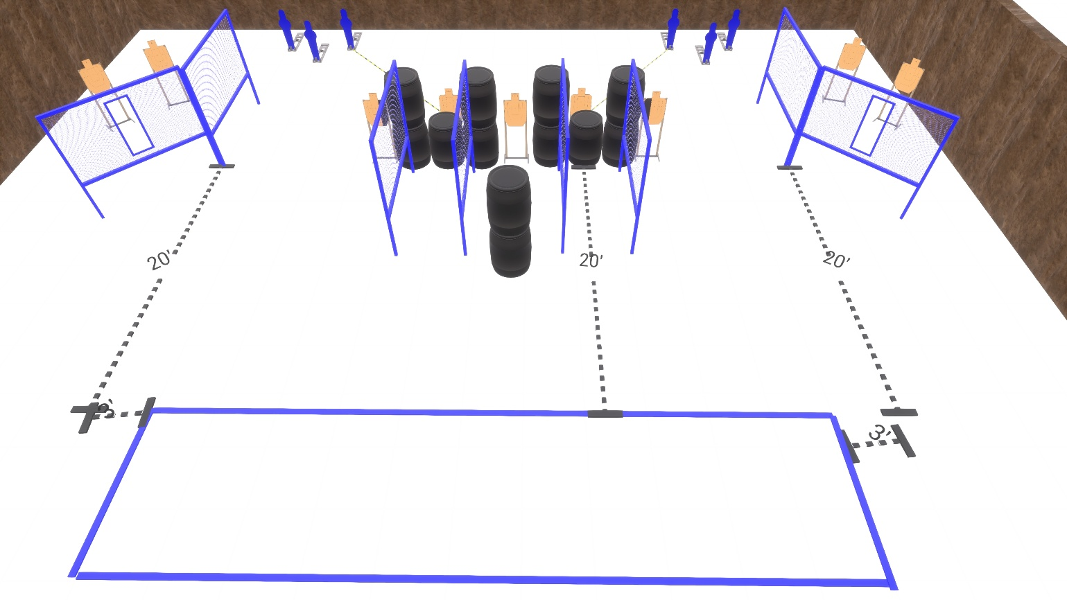

Written Stage Briefing:

Stage 6 – Home Port - is a 33 round, 165 point, Comstock Course. There are 9 cardboard targets and 6 steel targets.

The best 3 hits per paper will be scored.

Start Position: Anywhere.
Handgun is loaded and holstered, wrists below belt.
PCC is loaded held in both hands, stock on belt.

On the audible start signal, engage targets from within the shooting area.

USPSA / NROI Range Commands:
- Make Ready
- Are you ready?
- Standby
- If finished, unload and show clear
- If clear, hammer down and holster (Handgun)
If clear, hammer down and flag (PCC)
If clear, cylinder closed and holster (Revolver)
- Range is clear

Setup Notes:
12 Single Wall Stands
2 Double Wall Stands
6 Full Walls
2 Port Walls
9 Target stands / 18 target sticks
2 Aaron Banks Bobbers + activation cables
4 Poppers + bases
2 Activator Poppers + hardware
12+ barrels


